## Section 1: Practical project: Modeling, Building a Data Warehouse for Gravity Bookstore

### Use-case Background

Gravity Bookstore is a database for a fictional bookstore called that captures information about books, customers, and sales.

Please download the SQL files from the link below and run them in a new database named ‘gravity_books’ in your local SQL Server DB engine:

ERD of ‘gravity_books’ transactional database:

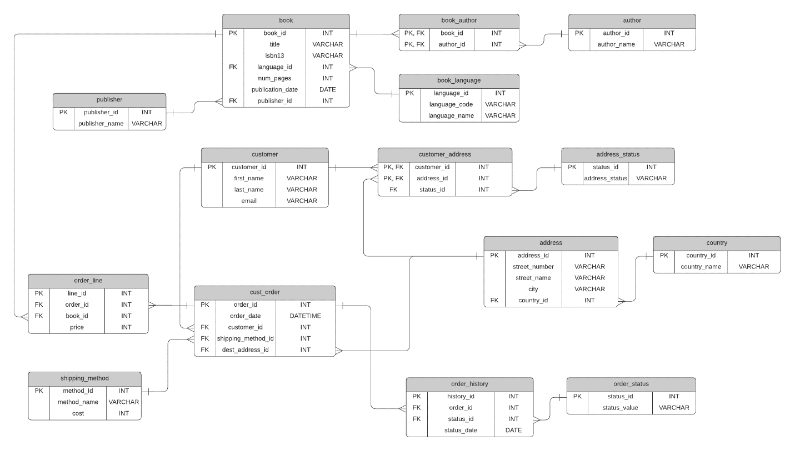

Tables description:

* **book**: a list of all books available in the store.
* **book_author**: stores the authors for each book, which is a many-to-many relationship.
* **author**: a list of all authors.
* **book_language**: a list of possible languages of books.
* **publisher**: a list of publishers for books.
* **customer**: a list of the customers of the Gravity Bookstore.
* **customer_address**: a list of addresses for customers, as a customer can have more than one address, and an address has more than one customer.
* **address_status**: a list of statuses for an address, because addresses can be current or old.
* **address**: a list of addresses in the system.
* **country**: a list of countries that addresses are in.
* **cust_order**: a list of orders placed by customers.
* **order_line**: a list of books that are a part of each order.
* **shipping_method**: the possible shipping methods for an order.
* **order_history**: the history of an order, such as ordered, cancelled, delivered.
* **order_status**: the possible statuses of an order.

Requirements

1. Model and develop ‘gravity_books_dwh’ Data Warehouse
   1. Please provide the DDL statements of table creation and a screenshot from the DWH Diagram (Dimensional Modeling).
2. Define which approach (star schema, snowflake,Galaxy Schema) of data warehouse used in your solution, and why.
3. Define a method to check and maintain the integrity between the fact and the dimensions (SQL).
4. Please, add a date dimension to the system to track the historical changes.

* Please provide screenshots from the output of each point above:
* Compress the entire solution files:
  + DWH DDL statements (format . sql)
  + Mapping Sheet